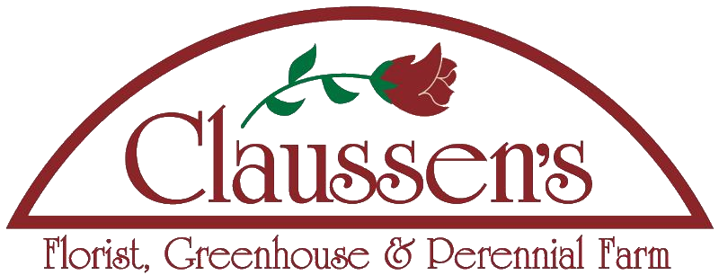
Florist, Greenhouse & Perennial Farm
187 Main Street, Colchester, VT 05446 (802) 878-2361
www.claussens.com e-mail: ali@claussens.com

Employment Application

We are an equal opportunity/affirmative action employer. All qualified applicants will be considered without regard to age, race, color, sex, religion, national origin, marital status, ancestry, citizenship, veteran status,

Full Name: ______________________________________________ Today’s Date: ____/_____/____

Phone: ____________________________________ Alternate Phone: ____________________________

E-mail Address (Necessary to complete this form): __________________________________________________
___
Referral Source: _________________________________________________

Mailing Address: _____________________________________________________________________________

City: __________________________________ State: __________ Zip code: _________________

Are you 18 years of age or older? _________ Are you authorized to work in the United States? ________

What language(s) do you speak? ________________________________________________________________

Please explain below why you are interested in the Greenhouse Production Position. Feel free to add any experiences and strengths that would assist us in selecting you.
** Requires shared weekend work responsibility

____________________________________________________________________________________________________________________________________________________________________________________________________________________________________________________________________________________________________________________________________________________________________________________________
________________________________________________________________________________________________________________________________________________________
________________________________________________________________________________________________________________________________________________________

Work Availability:
This is a Full Time Position only (40+ hours)
Available Start Date: ___________________

Are there any days or hours you are NOT available to work?
(Please note that specific positions require shared weekend work responsibilities)

Date’s Not Available: ___________________________________________________________________
_________________________________________________________________________________________

EDUCATION HISTORY:
Level: | Name & Location: | Course of Study: | # of Years Completed | Year Graduated | Degree or Diploma
High School
Vocational, Technical or Junior College
College or University
Licenses or Certificates
Other
~~~~~~~~~~~~~~~~~~~~~~~~~~~~~~~~~~~~~~~~~~~~~~~~~~~~~~~~~~~~~~~~~~~~~~~~~~~~~~~~~

Please list your previous work experience starting with the most recent employment.
This section must be completed regardless of additional attachments.

Employer Name/Address: ________________________________________ May we contact them? Y N

Supervisor's Name: _________________________________________ Phone #: _____________________

Start Date: ________________ End Date: _____________ Reason for leaving: __________________________

Position: __________________ Duties: ____________________________________________ Salary: ___________

Employer Name/Address: ________________________________________ May we contact them? Y N

Supervisor's Name: _________________________________________ Phone #: _____________________

Start Date: ________________ End Date: _____________ Reason for leaving: __________________________

Position: __________________ Duties: ____________________________________________ Salary: ___________

Employer Name/Address: ________________________________________ May we contact them? Y N

Supervisor's Name: _________________________________________ Phone #: _____________________

Start Date: ________________ End Date: _____________ Reason for leaving: __________________________

Position: __________________ Duties: ____________________________________________ Salary: ___________

Please provide three references that we can contact who will attest to your character and work ethic.

Name: ____________________________________ Business: ________________________ Phone #: __________________

Mailing Address: _______________________________ Town: ____________________ State: _______ Zip: ___________

Relationship: ________________________________________________ # of Years Acquainted: __________________

Name: ____________________________________ Business: ________________________ Phone #: __________________

Mailing Address: _______________________________ Town: ____________________ State: _______ Zip: ___________

Relationship: ________________________________________________ # of Years Acquainted: __________________

Name: ____________________________________ Business: ________________________ Phone #: __________________

Mailing Address: _______________________________ Town: ____________________ State: _______ Zip: ___________

Relationship: ________________________________________________ # of Years Acquainted: __________________

I authorize Claussen's Florist & Greenhouse to inquire into my educational, professional and employment records, background, references and any other information deemed necessary relating to my suitability for employment. I hereby give my consent to authorize others, including my current employer (if applicable), to provide employment-related information about me to Claussen's Florist & Greenhouse and will hold Claussen's, my former employers and others harmless from any claim made on the basis that such information about me was provided, or that any employment decision was made on the basis of such information. I state that the above information is true and correct. I understand that the hiring process will be terminated (or in the event of my employment with Claussen's Florist & Greenhouse I shall be subject to dismissal) if any information that I have provided in this application, resume, interview or any part of the hiring process is false, misleading, omitted information requested, or if I have withheld relevant information, regardless of the time elapsed after discovery. I further understand that nothing in this application process is intended to create an employment contract and entering into this process does not indicate that a position is open or obligate Claussen's Florist & Greenhouse to hire me.

I hereby acknowledge that I have read and agree to the above statements.

Signature: _____________________________________________________ Date: ____/_____/_____

